Engaging Muscogee, Cherokee, & Intertribal Indigenous Knowledge
While Teaching Books by Cynthia Leitich Smith & Traci Sorell

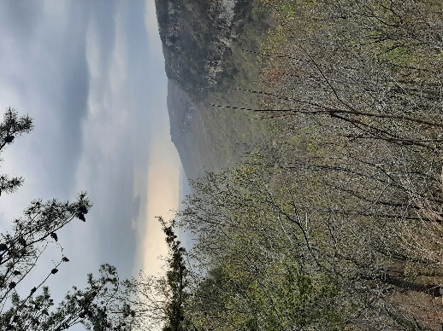
“I look on Native Women’s writing as a gift, a give-away of the truest meaning. Our spirit, our sweat, our tears, our laughter, our love, our anger, our bodies are distilled into words that we bead together to make power. Not power over anything. Power. Power that speaks to hearts as well as to minds.”

–Beth Brant (Mohawk), “The Good Red Road”
How can you deepen your understanding of the power of Indigenous stories & knowledge? How can you identify more Indigenous voices to engage when teaching youth literature by Smith, Sorell, and other Indigenous authors?

- Start with texts referenced in the books themselves, along with texts provided on author & publisher websites.
  - Some texts referenced in Smith’s Hearts Unbroken: Tim Tingle’s books, Eric Gansworth’s books, the (amazing!) Native America Calling radio program podcast, and the Mvskoke Nation Language App.

  - Some texts referenced in Sorell’s We Are Still Here: Donald Fixico’s Termination and Relocation: Federal Indian Policy, 1945-1960, David Treuer’s The Heartbeat of Wounded Knee: Native America from 1890 to the Present, and the United Nations’ Declaration on the Rights of Indigenous Peoples.

- Check out texts by other writers, artists, & leaders from the same Indigenous nation(s) as the authors.
  - Some Muscogee writers to engage alongside Smith’s work include Joy Harjo, Craig Womack, Jennifer Foerster, Laura Harjo, and Sarah Deer. Engage visual art, film, and TV, too, like Sterlin Harjo’s many great feature films and documentaries (and his Netflix series, Reservation Dogs) and the open-access film, Hearing the Call: The Cultural and Spiritual Journey of Rosemary McCombs Maxey. Also explore official websites of the Muscogee Nation, College of the Muscogee Nation, and Muscogee-led organizations that interest you and your students.

  - Some Cherokee writers to read in conversation with Sorell include Daniel Heath Justice, Kirby Brown, Blake Hausman, Kim Shuck, Mary Kathryn Nagle, and Adrienne Keene. Sorell’s biography of Wilma Mankiller comes out soon; I look forward to reading it alongside Mankiller’s autobiography, Mankiller: A Chief and Her People and the feature film Mankiller inspired, The Cherokee Word for Water. Also check out the official website of the Cherokee Nation. With Sorell’s co-authored Indian No More, engage Umpqua voices as well. The Confederated Tribes of Grand Ronde website is a good place to start.

- Go topical.
  - Find Native-produced news media sources, websites, essays, and books on topics the authors address. Some of the many topics worth further study that Smith and Sorell represent in their books are US federal Indian policy, termination/relocation, cultural appropriation, Native Americans’ military service, Indigenous political activism (past and present), Indigenous approaches to science education, Indigenous leaders in STEM, Indigenous language revitalization, powwows, and the sovereign status of Native nations.

  - Two topics Smith (and few others) represents are experiences of folks with multiple tribal affiliations & experiences of Black Native Americans. Her novel Rain Is Not My Indian Name, especially, portrays characters self-reflectively inhabiting multiple tribal, ethnic, and racial identities. You could further engage these topics by reading Melissa Tantaquidgeon Zobel (Mohegan)’s YA novel Wabanaki Blues as well as some of the stories in Ancestor Approved. You could also study writing & artwork by Freedmen descendants and others who identify as Black and Indigenous (like one of the characters in Rain does), including work by artist/activist Amber Starks, who is African American, a Muscogee Nation citizen, and also of Shawnee, Yuchi, Quapaw, and Cherokee descent.

- Go bold.
  - Critical race theory and tribal critical race theory are highly relevant lenses for studying Smith’s and Sorell’s books (and our lived realities!). Check out scholarship by Bryan McKinley Jones Brayboy (Lumbee), Jeanette Haynes Writer (Cherokee), and others. One of my personal favorites is the book American Indian Education: Counternarratives in Racism, Struggle, and the Law by Matthew Fletcher (Grand Traverse Band of Ottawa and Chippewa Indians).

  - Indigenous erotics offers another productively bold lens for engaging portrayals of gender, sexuality, oppression, joy, and empowerment in Indigenous youth literature by Smith, Sorell, and others. Check out work in this area by Beth Brant, Daniel Heath Justice, Deborah Miranda (Ohlone Costanoan Esselen Nation/Chumash), and other Indigenous writers. Also see my forthcoming Studies in the Novel article “Decolonizing Desire: The Indigenous YA Erotics of Cynthia Leitich Smith’s Hearts Unbroken.”
Find a copy of this handout, along with other resources for learning more about Indigenous nations and Indigenous youth literature, on the home page of my website, mandysuhrsytsma.weebly.com.

