Anishinaabe Lenses for Engaging Dawn Quigley’s Work

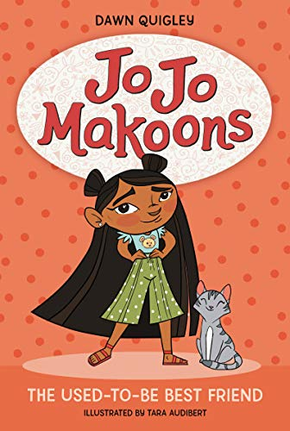
“Let me tell you about myself. I am seven years old and in the first grade. My name is Jo Jo Makoons Azure. You wanna know another way of saying that, in Ojibwe? (That’s the name of my Native American tribe!) Try saying: ‘Jo Jo Makoons Azure nindizhinikaaz.”
Big last word right? You sound out that last word like this: nin-DEZH-in-i-kauz.
Got it? If you can say Tyrannosaurus rex, you can say nindizhinikaaz.
But my real big name is Josephine Makoons Azure. Mama says Moushoom gave me the name Makoons because when I was a baby, I growled and had short black hair—just like a little bear cub! You say Makoons like this: ma-KOONS.”
--Jo Jo Makoons: The Used-To-Be Best Friend (pp. 3-4)

Check out Quigley’s Large (and Growing!) Body of Work for Young People, Teachers, and Scholars.
Quigley’s youth titles include early chapter books in her Jo Jo Makoons series, her YA novel Apple in the Middle, her non-fiction picture book Native American Heroes, and her story “Joey Reads the Sky” in Ancestor Approved: Intertribal Stories for Kids. A veteran educator/scholar/author, Quigley also has over 30 published articles, essays, and poems. A personal favorite is her profound 2016 American Indian Quarterly article, “Silenced: Voices Taken from American Indian Characters in Children’s Literature.” That one should be required reading for all of us who study youth literature. See Quigley’s website, dawnquigley.com, and her publisher sites for more. Also check out the official website of Quigley’s tribal Nation, The Turtle Mountain Band of Ojibwe (tmchippewa.com).

Some Suggested Works by Anishinaabe Authors to Read alongside Quigley’s Books for Young People
Centering Anishinaabeg Studies: Understanding the World through Stories. Ed. Jill Doerfler, Niigaanwewidam James
Sinclair, & Heidi Kiiwetinepinesiik Stark. Michigan State UP, 2013.

Erdrich, Louise. Everything! Especially all the books in the Birchbark House middle grade fiction historical chapter
book series (Birchbark House, The Game of Silence, The Porcupine Year, Chickadee, & Makoons).

Gross, Lawrence. Anishinaabe Ways of Knowing and Being. Routledge, 2014.

Kimmerer, Robin Wall. Braiding Sweetgrass: Indigenous Wisdom, Scientific Knowledge, and the Teachings of Plants. Milkweed,
2013.

Noodin, Margaret. Bawaajimo: A Dialect of Dreams in Anishinaabe Language and Literature. Michigan State UP, 2014. Also check out Noodin’s bilingual poetry, her online talks, and the Anishinaabemowin language website she manages, Ojibwe.net.
Simpson, Leanne. Dancing on Our Turtle’s Back: Stories of Nishnaabeg Re-creation, Resurgence and a New Emergence. Arbeiter Ring, 2011. And As We Have Always Done: Indigenous Freedom through Radical Resistance. U of MN P, 2017.

Treuer, Anton, et al. Awesiinyensag: Dibaajimowinan Ji-Gikinoo'amaageng. Wiigwaas Press, 2010. And Ojibwe in
Minnesota. MN Historical Society Press, 2010.

Vizenor, Gerald. Manifest Manners: Narratives on Postindian Survivance. U of Nebraska P, 1999.
Find a copy of this handout along with other resources for learning more about Indigenous nations and Indigenous youth lit on the home page of my website, mandysuhrsytsma.weebly.com.

